WEEK 11
Week Ending: |  | DAY: |  | Subject: Social Studies
Duration: |  |  |  | Strand: Environment
Class: B7 |  | Class Size: |  | Sub Strand: Understanding Our Natural World
Content Standard:  B7.1.3.2 Assess the issue of natural disasters and their management |  |  | Indicator:  B7.1.3.2.1. Examine natural disasters in the environment. |  | Lesson:  1 OF 3
Performance Indicator:  Learners can examine natural disasters in the environment. |  |  |  | Core Competencies:  Creativity and Innovation, Comm & Collaboration, Digital Literacy,  Critical thinking and Problem solving.
References: Social Studies Curriculum Pg. 9 -10
Phase/Duration | Learners Activities |  |  |  |  | Resources
PHASE 1: STARTER | Revise with learners to review their understanding in the previous lesson.  Share performance indicators with learners.
PHASE 2: NEW LEARNING | Revise with learners some examples of natural disasters.  Example: flooding, earthquake, etc.  Brainstorm learners for the meaning of flooding.  Flooding is the over flowing of water onto land that is normally dry.  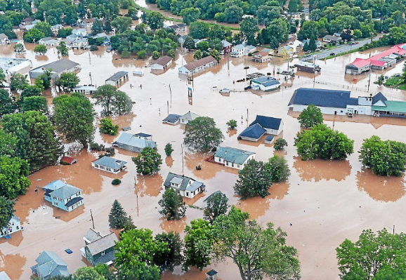  Guide learners to discuss the causes of flooding.  - Heavy rains  - Overflowing rivers  - Collapsed dams  - Snowmelt  - Climate change  In groups, let learners discuss the effects of flooding.  Example:  - Loss of human life  - Damage of property  - Destruction of crops  - Loss of livestock  - Deterioration of health conditions owing to waterborne disease  Again, engage learners to discuss the causes and effect of earthquake.  Earthquake, also known as tremor or temblor, is the shaking of the surface of the earth resulting from a sudden release of energy in the earth’s lithosphere that creates seismic waves.  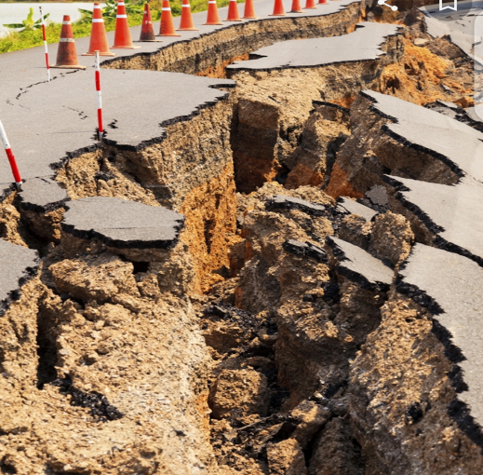  When the stress on the edge overcomes the friction, there is an earthquake that releases energy in waves that travel through the earth’s crust and causes the shaking that we feel.  Assessment  - Identify and explain three causes of flooding.  - Explain three effects of Earthquake. |  |  |  |  | Pictures and Charts
PHASE 3: REFLECTION | Use peer discussion and effective questioning to find out from learners what they have learnt during the lesson.  Take feedback from learners and summarize the lesson.

Week Ending: |  | DAY: |  | Subject: Social Studies
Duration: |  |  |  | Strand: Environment
Class: B7 |  | Class Size: |  | Sub Strand: Understanding Our Natural World
Content Standard:  B7.1.3.2 Assess the issue of natural disasters and their management |  |  | Indicator:  B7.1.3.2.1. Examine natural disasters in the environment. |  | Lesson:  1 OF 2
Performance Indicator:  Learners can examine natural disasters in the environment. |  |  |  | Core Competencies:  Creativity and Innovation, Comm & Collaboration, Digital Literacy,  Critical thinking and Problem solving.
References: Social Studies Curriculum Pg. 9 -10
Phase/Duration | Learners Activities |  |  |  |  | Resources
PHASE 1: STARTER | Revise with learners to review their understanding in the previous lesson.  Share performance indicators with learners.
PHASE 2: NEW LEARNING | Revise with learners some examples of natural disasters.  Example: wildfire, earthquake, landslide, etc.  Brainstorm learners for the meaning of Wildfire.  Wildfire is an unplanned, uncontrolled and unpredictable fire in an area of combustible vegetarian starting in rural and urban areas..  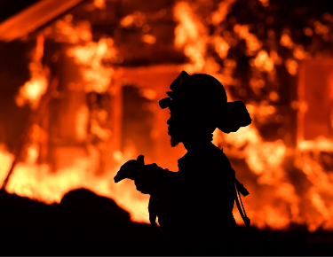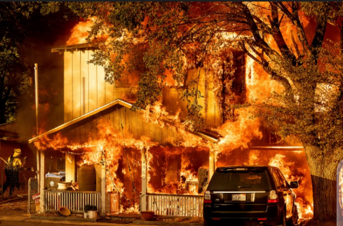  wildfire  Guide learners to discuss the causes of Wildfire.  - Burning debris  - cigarette  - Lighting  - Fireworks  - Volcanic eruption  In groups, let learners discuss the effects of Wildfire.  Example:  - Loss of human life  - Damage of property  - Destruction of crops  - Loss of livestock  Again, engage learners to discuss the causes and effect of landslide.  Landslide is the movement of a mass of rock, debris, or earth down a slope.  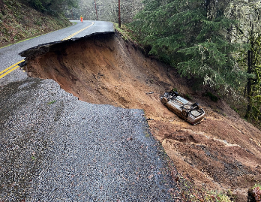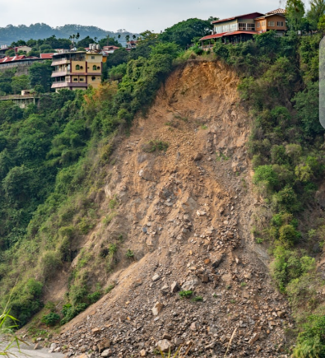  Landslide  Causes of landslides  - Deforestation  - Shifting cultivation  - Heavy rainfall and earthquakes  - Mining  - Urbanization.  In groups, learners discuss the effects of landslide on humans and properties.  Loss of life  Destruction of infrastructure  Damage to land, etc.  Leaders of each group presents their findings to the whole class. Encourage learners to ask questions after each presentation.  Assessment  - State and explain any three causes and effects of landslide  - State and explain any three causes and effects of wildfire |  |  |  |  | Pictures and Charts
PHASE 3: REFLECTION | Use peer discussion and effective questioning to find out from learners what they have learnt during the lesson.  Take feedback from learners and summarize the lesson.

Week Ending: |  | DAY: |  | Subject: Social Studies
Duration: |  |  |  | Strand: Environment
Class: B7 |  | Class Size: |  | Sub Strand: Understanding Our Natural World
Content Standard:  B7.1.3.2 Assess the issue of natural disasters and their management |  |  | Indicator:  B7.1.3.2.1. Examine natural disasters in the environment. |  |  | Lesson:  2 OF 2
Performance Indicator:  Learners can describe how to manage natural disasters in the environment. |  |  |  |  | Core Competencies:  Creativity and Innovation, Comm & Collaboration, Digital Literacy,  Critical thinking and Problem solving.
References: Social Studies Curriculum Pg. 9 -10
Phase/Duration | Learners Activities |  |  |  |  |  | Resources
PHASE 1: STARTER | Revise with learners to review their understanding in the previous lesson.  Share performance indicators with learners.
PHASE 2: NEW LEARNING | Engage learners to discuss ways to managing natural disasters.  Example: How to reduce the risk of;  Landslides  - Modifying slope geometry  - Using chemicals agents to reinforce slope material  - Installing structures such as piles and retaining walls  - Grouting rock joints and fissures  - Diverting debris pathways, etc.  Wildfire  Check weather and drought conditions  Build campfire in an open location and far from flammables  Keep vehicles off dry grass  Regularly maintain your equipment and vehicles, etc.  Guide learners to discuss the role of institutions responsible for early detection and management of natural disasters in Ghana, including Ghana Meteorological Agency (GMA), National Disaster Management Organisation (NADMO).  Assessment  - State four functions of the Ghana Meteorological Agency (GMA)  - Briefly explain the role of the National Disaster Management Organisation (NADMO) |  |  |  |  |  | Pictures and Charts
PHASE 3: REFLECTION | Use peer discussion and effective questioning to find out from learners what they have learnt during the lesson.  Take feedback from learners and summarize the lesson.

